* *Chapter 1 :- WHY SHOULD YOU LEARN TO WRITE PROGRAMS?*

*Exercise 1 :-*

***1} what is the function of the secondary memory in a computer?***

1. ***Execute all of the computation and logic of the program.***
2. ***Retrieve web pages over the Internet.***
3. ***Store information for the long term, even beyond a power cycle.***
4. ***Take input from the user.***

***Ans :-*** *Storing Information for Long Term, Even Beyond The Power Cycle.*

***2} What is a program?***

***Ans :-*** *A program is a Combination of Statements Ordered in a Structured manner to perform a Specific Task. It is a set of instructions that speciﬁes a computation.*

***3} What is the difference between a compiler and an interpreter?***

***Ans :-*** *A Compiler Compiles Entire Program at Once whereas Interpreter Checks each statement Line By line & Compiles Them.*

* An **interpreter** reads the source code of the program as written by the programmer, parses the source code, and interprets the instructions on the ﬂy. Python is an interpreter and when we are running Python interactively, we can type a line of Python (a sentence) and Python processes it immediately and is ready for us to type another line of Python.
* A ***compiler*** needs to be handed the entire program in a ﬁle, and then it runs a process to translate the high-level source code into machine language and then the compiler puts the resulting machine language into a ﬁle for later execution.

***4} Which of the following contains “machine code”?***

***a) The Python interpreter***

***b) The keyboard***

***c) Python source ﬁle***

***d) A word processing document***

***Ans :-*** *Python Source Code.*

***5} What is wrong with the following code:***

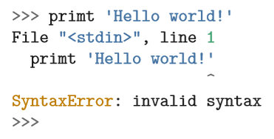

***Ans :-*** *It’s a Syntax Error as The keyword “Print” is Typed incorrectly as “primt”.*

***6} Where in the computer is a variable such as “x” stored after the following Python line finishes?***

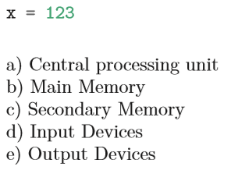

***Ans :-*** *Main memory.*

***7} What will the following program print out:***

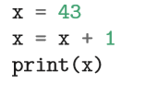

***Ans :-*** *44.*

***8} Explain each of the following using an example of a human capability: (1) Central processing unit, (2) Main Memory, (3) Secondary Memory, (4) Input Device, and (5) Output Device. For example, “What is the human equivalent to a Central Processing Unit”?***

***Ans :-***

*1} CPU :- Cortex.*

*2} Main Memory :- Brain.*

*3} Secondary Memory :- Thalamus.*

*4} Input Devices :- Sensory Organs.*

*5} Output Devices :- Reflexes & Response Organs*

***9} How do you fix a “Syntax Error”?***

***Ans :-*** *You can Mitigate the Syntax error by checking Out for Syntax Mistakes That You Might have made in your Code and Correcting the Syntax with Right keywords or Statement.*